“Then the Lord put out his hand and touched my mouth, And the Lord said to me,
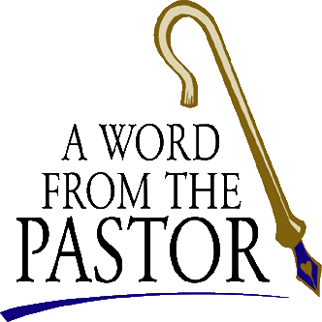
“Now I have put my words in your mouth” Jeremiah 1.9

In the beginning of March the Trinity Council met at Berg Haus, a retreat center over by Hill Lutheran Church in Cleona. We spent the day discussing the future of our church, our visions, and the best way to accomplish our mission. The overall consensus was to improve and create more ways to communicate between members and guests. With God’s help, we will strive to share with you discussions regarding activities, additions and alternatives being considered – for the spiritual health of Trinity. We realize the need to stay connected throughout the week. As pastor, I will weave God’s Word into emails, prayer services and other means of communication keeping Jesus in our hearts and minds daily. A written prayer is included in the bulletin with the hope that it might comfort and encourage you to offer up to God words of your own. Council pledges to keep you abreast of all things through Sunday morning announcements, worship bulletin, Tidings, bulletin board, email, texting, phone calls, website and Facebook (and soon a TV monitor). As we seek to better serve Christ we ask that you be part of this endeavor. Commitment and communication are a two way street. Like a family unit, each person in the home is responsible for a smoothly run household. A parent would not permit one child to do less than the other. Each individual is asked to participate as able, considering age and experience. The same goes for the church. It is not about who has more time, talent or treasure but who has the passion and commitment to live their lives according to the gospel. When you grow in Christ you are excited about committing more of your life to serve God.
“Together with all the Lord's holy people, [we will] grasp how wide and long and high and deep is the love of Christ” (Eph. 3.18) and how wide and long and high and deep is our love for Christ. Commitment, Communication, Church and Christ all begin with the letter C. In a world that offers us complicated and complex ways to consume our lives, Christ is the One and only reason for which we live and breathe. We are One in Christ so if you have an idea, a concern, or a vision please share it with one of your church leaders or me. We are excited about the newness each day brings as we anticipate the awakening of springtime and the promise that God will be with us always. As we wrap up our 40 days of meditation in the Lord’s commitment to us, let Holy Week be the final trek. Breathe in the love of the sacrificial lamb – the One who willingly walked to the hill, and who with outstretched arms communicated to us just how much God loves each and every one of us.
“Amen, Come Lord Jesus!
Revelation 22.20b

Pastor Cheri

