Trinity Tidings
April 2018

“And let the peace of Christ reign in your hearts, to which indeed you were called in the one body. And be thankful.” Colossians 3:15

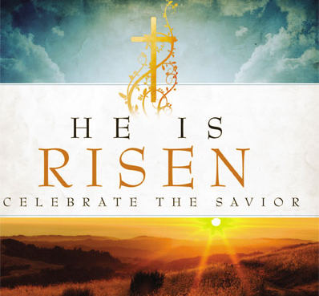
John S. Mogabgab, in Diversity and the Peace of Christ, writes that “Paul was convinced that practicing the art of peace was essential to the meaning of the church.” I couldn’t agree with him more. We all have a part to play, especially as Christians. Peace can be achieved through the many opportunities presented to each of us. We can further the kingdom for God and for that we ought to be eternally grateful. But first we must believe that we can achieve peace and that each one of us is crucial to its inception. Mogabgab says “Blessing is the art of being spiritually present to others, in prayer, asking God to surround a particular person or situation with love, healing, and peace.” And I believe this simple DIY exercise in prayer is all it takes.
Find a quiet comfortable spot where, for a few moments without interruption, you can withdraw from the demands of life. Next breathe in and out, slowly; inhale the ever present Holy Spirit while exhaling any built up stress. You will feel as if you are cuddling in God’s warm embrace while enjoying the sanctuary of a loving God. Relax, stay for a while; dwell in the amazing awareness of such heavenly happiness. Savor the softness and serenity that can only be found in His sacredness. Now pray for yourself, focusing on the “light and warmth of God’s love as it surrounds you. Rest in that light and warmth while praying, ‘Bless me, God, with your love. Bless me with your healing. Bless me with your peace.’” Next pray for those close to you and then for those you do not know. Finally pray for your enemies (Yes even they merit prayers). Each time pray the blessing of peace; “Bless them, God, with your love. Bless them with your healing. Bless them with your peace.” Let the Holy Spirit do the work of the Wonderful Counselor, Mighty God, Everlasting Father, Prince of Peace. Then celebrate the unbelievable joy that this cross brings to all people. Find peace in a risen Christ!
Alleluia, Christ is Risen, Alleluia!

“May the God of hope fill you with all joy and peace in believing, so that you may abound in hope by the power of the Holy Spirit” Romans 15:13

Pastor Cheri

