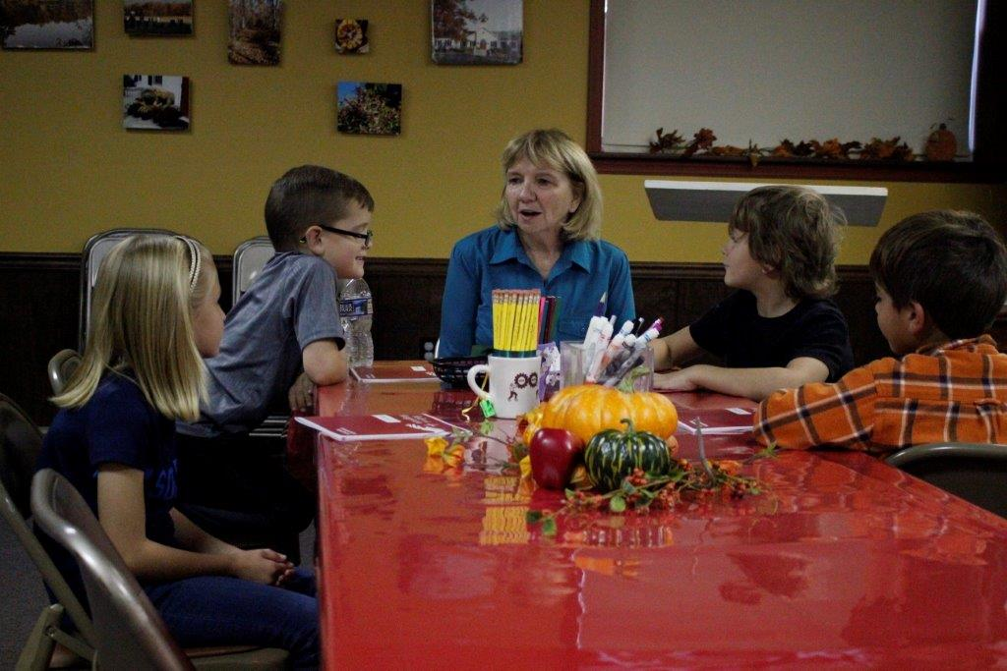
Trinity Tidings
January 2018

Then Jesus called the children over to him and said to the disciples, “Let the little children come to me! Never send them away! For the Kingdom of God belongs to men who have hearts as trusting as these little children’s. And anyone who doesn’t have their kind of faith will never get within the Kingdom’s gates.” Luke 18:16-17 (TLB)
Tommy wouldn’t sit still in Sunday school. He was “a corker.” The Christmas program was coming, and the teachers had a great idea: the children would be animals, as in “The Friendly Beasts.” They’d wear their footed pajamas and “give gifts” to baby Jesus. The kids were enthusiastic: “I’ll be a bluebird,” volunteered one. “I want to be a goat,” said another. Tommy yelled, “I’ll be the monkey,” as he pranced around. Tommy missed rehearsal. “Oh, no,” worried the teachers, “Tommy might say anything.” When program time came, the teachers smiled; Tommy was still missing. They could relax. At the last minute, in galloped Tommy. “You must be quiet,” whispered the teachers as they attached his tail and ears. “OK,” Tommy said. The children sat on the steps in front of the altar and took turns at the microphone. Little bluebird began, “I will sing to baby Jesus.” The goat said she would give cheese to the holy family. The horse offered rides, and the duck, feathers. Finally, the rabbit declared he’d share his soft fur. Tommy grinned, somersaulted down the steps, leapt up, and shouted, “I will teach baby Jesus to laugh!” The congregation clapped and laughed. Jesus may have laughed, too. (Beth Hunnicutt, Christmas Pageant Bloopers, Living Lutheran)

This kind of perspective reminds us just how intuitive yet creative children can be. And though we might not be able to prevent or predict what will come out of their sweet little mouths, we ought to enjoy every moment and maybe even learn a lesson or two. But let’s not take for granted that our children and grandchildren even know the birth story. So in this New Year let’s make a pact that we try our best to share God’s love story with our little ones. We can be intuitive and creative even as adults! Remember, there are ways to ensure our kids don’t miss out on the greatest story ever told. Some read the Christmas story on Christmas Eve or right before the gifts are opened. Others make a game out of it, or put a Nativity up while describing that beautiful night, while others teach the song “Away in the Manger” or simply point out the miracles that happen this time of year. Christmas is a time when all the family is together and you have everyone’s attention. Don’t let the simple gift of telling about the birth of baby Jesus slip through the cracks of Christmas chaos. Take a few minutes to share the reason for the season so that our young people through hearing will be able to retell the story. Perhaps they haven’t grown up in the church, ever been to Sunday school, or have parents who have neglected to tell them. Tradition lends special smells, sounds and song that will surround their memories as they recall the story of baby Jesus. I am pretty sure that will make Jesus smile and maybe even laugh as he watches.

Our mouths were filled with laughter, our tongues with songs of joy. Then it was said among the nations “The Lord has done great things for them.” Psalm 126:2

May your 2018 be filled with stories old and new.
Pastor Cheri

