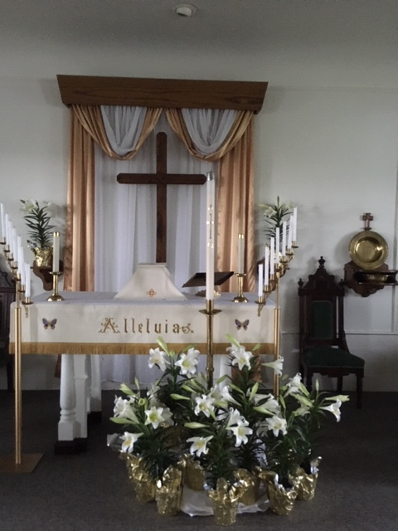
May 2019
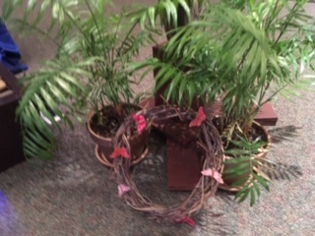
Trinity Tidings

“Do not be conformed to this world, but be transformed by the renewing of your minds, so that you may discern what the will of God— what is good and acceptable and perfect! So we, who are many, are one body in Christ and individually we are members one of another.” Romans 12:2 & 5 (NIV)

Many often comment on how tired I must be after Easter is over. As the day wanes into evening I have to admit yes indeed I am. A forty day journey with the congregation, in remembrance of our Savior’s amazing walk to Calvary concluded by meaningful and somber Maundy Thursday and Good Friday services not only exhaust my mental and spiritual energy but emotionally it can be draining. If you were unable to attend any of these beautiful events you really missed out! From the yummy soup suppers, fish fry, movie night to the first annual Lenten Luncheon God worked through many hands and voices. From Holy Week services to Easter sunrise service, breakfast, second service and craft and egg hunt where many innovative hands and hearts honored Christ in amazing ways (which never cease to amaze me) I wish you could’ve been part of these experiences. The preparations throughout Lent and up through Easter are incredible and take many people to make it happen in the way we envision it should be...which is to honor Christ. It could not be done without these wonderful servants of God. And so yes, I am exhausted, and so are others in our Trinity Family who commit enthusiastically with endless creativity until the work is done. God’s blessings to you who made our Lent and Easter experiences perhaps the best ever. Of course each year portrays the tenderness of God’s work through His grace and will continue to surprise and ignite us in years to come.
As we welcome spring and new life because of Christ Jesus, the earth’s beauty awakens right in step with our thirsty hearts and minds. We go from the barren, dormant thoughts to brighter positive passion. The ongoing thrill of new blossoms peaking their heads above ground and the progressively greener trees are similar to the excitement of that of our love for God and His gift of His only Son. However, just as spring fades, so we also tend to lose the joy and promise of the Resurrection. We are inclined to live in the moment and then move on. Just as summer comes and goes, followed by fall and winter so do our attitudes lose passion to the challenges of everyday living. It is as if we cannot hold on to that beautiful feeling that God offers us this time of year. How can we keep the anticipation of Easter morning alive in our hearts all year long? What can we do differently this year to retain the enthusiasm of being Easter people? Come and see what’s happening at Trinity and be refueled. Every week there is something just for you, as we support each other, grow through each other, and plant new seeds in and among each other. We are in this together. Paul reminds us we are “the body of Christ, and each one of [us] is a part of it.” (1st Corinthians 12:27)
Alleluia, Christ Is Risen! Praise God that we are part of that resurrection!
See you in church and around, Pastor Cheri

