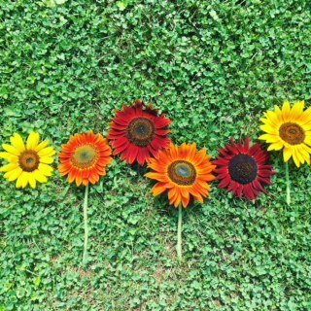
Trinity Tidings
May 2018

“Consider the lilies, how they grow: they toil not, neither do they
spin yet I say unto you, even Solomon in all his glory was not
arrayed like one of these” Matthew 6.28b

Recently, I was asked to reflect on areas where I have seen evidence of God working in my life. Just a few short weeks before that I had prayed God would move the hearts of people I have yet to meet. With the understanding that the Holy Spirit will bring people to me at the right time I left it at that and didn’t dwell on the expectation that this prayer would be answered so quickly. So when I was asked this question it was easy for me to share, without hesitation, the many occasions I knew, without a doubt, I had seen the palpable presence of God. Without going in to detail I was able to recount a number of times I was touched spiritually. I realized God had painted a beautiful picture with divine movement and influence. The number of people who had crossed my path by that time, who made their way into my inner circle with their cares and concerns, was beyond my expectation.

It was then that I noticed the changing of my immediate surroundings in kaleidoscopic possibilities. An array of colors came together forming beautiful images, in my heart and in my mind, as I listened to their stories. Amazing and artful relationships were born as my days became brighter and more cheerful. I felt the warm embrace of our loving Savior offering hope in, what has seemed like, a long awaited gloomy period. Similar to the landscape when spring encroaches the dormant countryside, I grew. Doors opened and fresh air filled my lungs as each day the sun shone a little brighter, the rays a little warmer. A brilliance shone deeply in my soul as colors begin popping everywhere. My heart bloomed like the Cherry blossoms, Forsythia, Tulips and Hyacinths.

Soon there will be varieties of living plants dotting the earth as our Heavenly artist excitedly dabs tubes of paint on a palette and begins to splash colors across the canvas. I am encouraged and excited about the plans God has for me. I think about the movement of the Spirit intervening softly and tenderly always knowing the right time to add another brush stroke. I give thanks for new relationships and for conversations that stretch me and challenge me. Most importantly, I am grateful for each of these interactions recognizing how fulfilling it has been. I am reminded that everyone has a story to share. Everyone has a wonderful gift - a gift from God - that will inform my life...and always for the better. I thank God for every breath I take as the world once again comes alive!

“Instead, make yourselves beautiful on the inside, in your hearts, with the enduring quality of a gentle, peaceful spirit. This type of beauty is very precious
in God’s eyes”1 Peter 3.4
Pastor Cheri

