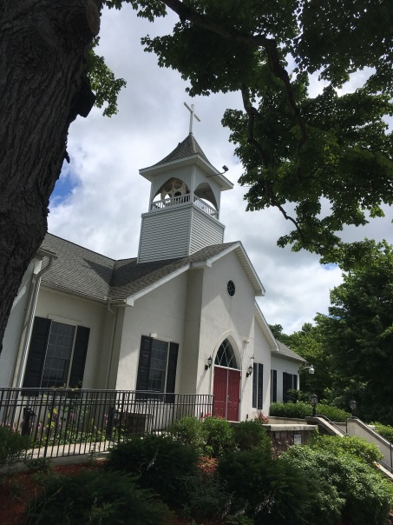
“Therefore I have gazed upon You in Your holy place, that I might behold Your power and Your glory. For Your loving- kindness is better than life itself; my lips shall give You praise. So will I bless You as long as I live and lift up my hands in Your Name”
Psalm 63:2-3
Trinity Tidings
April 2019

Our actions in worship are about the power and glory of a God who is made present
in our midst. We lift our voices together in song. We kneel and bow and reach out our hands. These rituals enact the gospel...and engage our senses so that touch, taste and smell all confirm the saving message we also hear.
Lasting Hope, March 25th 2019, pg43

A proponent of a regular worship habits, I believe we need to be reined in from a worldly week of the constant pull away from God. There is something special about the setting of worship that offers us time and space to eagerly open our hearts. It matters not if worship occurs in a building, home or outdoors, God will always offer His infiltrating Word through our participation. As we bow down, pray, sing and listen to scripture, the power and glory of God fills our worship space. Whatever my message may be I know the Spirit will take the words, from my lips and carry them to your ears, and deliver diverse thoughts and understanding depending on the individual need. The amazing gift of the Lord’s Supper, the bread and wine that engage our senses, the sound of running water of the baptismal water wall, along with all of our acclamations will meet a gently hovering Spirit. The amalgamations dance joyfully as God’s goodness and mercy return to us in extraordinary ways. You see God is pleased, so very pleased, to have our full attention, our open hearts and curious minds in one community.
It is through the righteousness and redeeming work of our Lord and Savior that we are one with God and free to accept His invitation. A few weeks ago the choir sang “Seek Ye First the Kingdom of God,” a beautiful rendition of Matthew 6:33 reminding us to humbly accept God’s request to come and be with Him. I see this overflow in to support, fellowship and new found relationships. When we take the time to get to know one another through our participation in the service before, during or after worship, later on over a cup of coffee, or in the mission field, there is value in such solidarity. I love being greeted by melodious chatter as I enter the fellowship hall where a range of conversations occur between those standing, sitting, or busily working the kitchen. This confirms that the Spirit is actively pursuing us from the moment we walk through the door. (Honestly, even before that as the Spirit probably nudged us out of bed!) As we enter the penultimate week of Lent, let Passion Sunday and Holy Week wrap up our journey where we will finally be fully prepared to welcome Christ the King! We will be ready for Easter, as we rejoice whole heartedly through unified worship. As we offer ourselves to God, God will create in us a desire to be more imaginative, more loving, more giving of every good blessing. All that is left then, my friends, are the praises meant for the precious and loving Son of God, Jesus Christ.
Alleluia, Christ Is Risen! Christ Is Risen Alleluia!
Pastor Cheri

