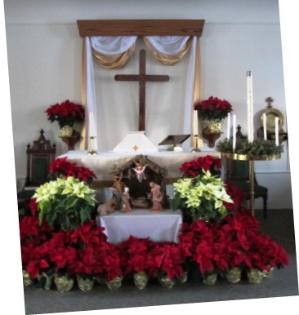
Trinity Tidings
December 2017

“For unto you is born ... a Savior, which is Christ the Lord” Luke 2:11
Over two thousand years ago, the angels proclaimed the arrival of the newborn king. A king who everyone thought had come to save the world from war and oppression so acutely felt in the country of Jesus’ time. But we know differently, we know Jesus came to save us in a more grand way than from just earthly enigmas. Jesus came, in the flesh, to bring us the one thing we could never achieve on our own, eternal life. He came to live and walk among us so that he could die and rise again conquering the power of death and the devil. This is probably not new news to any of us but it is the Good News we proclaim to the ends of the earth! It is the beginning of all that we believe. Without this birth there’d have been no savior to hang on the cross.
Writing this article before Thanksgiving and knowing you will read it before Advent begins I feel as if there is something else I should be sharing with you before Christmas actually arrives. Like some other bits of wisdom. In some ways it seems too early to think of Christmas. I guess we do get a little bent out of shape when Christmas songs begin playing so early in November. We don’t want to introduce the Christmas Spirit too early in case it should lose its meaning and sentimentality. In addition, some of us don’t like be dictated to by society and its whims, am I right?
While I don’t subscribe to bending to the will of the secular world I do think we can take advantage of the ringing of Christmas bells (be it the Salvation Army, the multitude of voices over the airwaves or the endless displays in our stores) and use these spiritual moments of Christmas to share the true meaning of this special time of year. And yes we can wish people a Merry Christmas. There is no law against it. If you work in an establishment that prohibits you from saying it to customers perhaps it is our role to ask why. Why is it that a society that tries to meet the needs of all people, strive to acknowledge all faiths, we as Christians are suppressed? How can we possibly believe it is okay to not wish one another the blessings of Christmas when that is our belief? Over the years we, as Christians, have let ourselves be pushed behind the confines of our buildings. We’ve allowed schools and other organizations dictate the place and time we can celebrate and profess our Christian faith. In lieu of all persons’ rights, we shouldn’t be in each other’s faces forcing our beliefs on one another but we can be honest and sincere in our own convictions. Wishing someone the love of Christ, sharing the gospel of salvation, is our commission...we are doing God’s work. We are taking that little bundle of salvation and filling lives with promise and hope. That is what Christmas is about and that is something we want to celebrate year ‘round. So bring on the Christmas music, get us in the holiday spirit and let us take advantage of this special time of year to lighten the load of those who are buried under the weight of worry. Let us proclaim the birth of a newborn King...the one who came to save all humanity.

“But the angel said to them, ‘Do not be afraid, for see – I am bringing you good news of great joy for all the people” Luke 2:10.
Pastor Cheri

