Trinity Tidings
February 2018
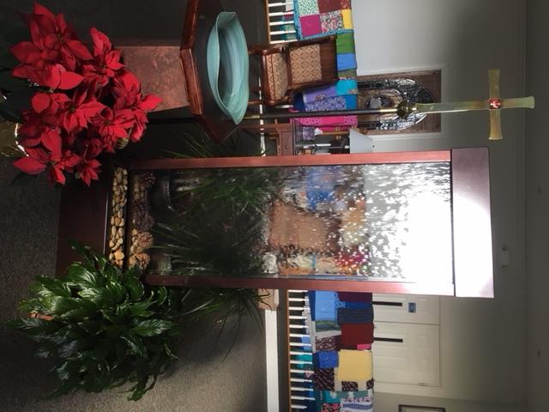

“For with you is the fountain of life; in your light we see light”
Psalm 36:9
January is coming to a close and soon the season of Epiphany will also be behind us. The season where light is the theme and God’s presence flows continuously. A light that put men on their knees in worship of a King. A light that never ends. After the anticipation of Jesus’ coming (Advent) and the excitement and realization of the Christ child (Christmas), Epiphany continues the celebration. Epiphany prepares us for Lent and reminds us there is always a light at the end of the tunnel. Throughout Epiphany we learn of God’s promise to shed light on our every step no matter who we are, where we come from, or what we face. A light that will prepare us for the upcoming 40 days and nights of Lent, as we focus on every step Jesus took toward Calvary. Lent and Holy Week take us through the saddest and darkest times in the church year ultimately leading us to the brightest time of the church year...Jesus’ resurrection (Easter).
We cannot get to the empty tomb, though, without experiencing life’s peaks and valleys. We cannot begin to understand our weaknesses or our desperate need for a Savior until we have endured trials of our own. When we think we have we have walked in His shoes, felt His pain and abandonment during the season of Lent, we realize there is no comparison. Though we fast from something we like to help us remember the sacrifices Christ made, it doesn’t even begin to scratch the surface. Giving up something is good, but giving to something or someone is even better. Maybe we can give up those extra lattes, sweets or a time consuming electronic vice for a while and give that extra money and time to a worthwhile cause. Doing more can sometimes feels like a sacrifice, to which John (16.22) tells us, “no one can take your joy from you.” Think about it, no hardship, not even our worst nightmare, cannot steal away God’s promise to live in us and bring us through our trials. Paul said to the Philippians, rejoice in the Lord always, don’t worry about anything, but tell God everything and then let God’s peace surround you and protect your heart always” (4-7)...“always” being the key.
We learn in Hebrews 13.8 that “Jesus is the same yesterday and today and forever,” meaning the light that shone on and in the manger that night, long ago, is the same light that shines in our lives today. The light that opened the hearts of the magi to the revelation of the Messiah’s pure presence awakens us in the same way. The same bright light that led them to safety leads us to our wellbeing. God showed the foreigners a different way home keeping them safe from King Herod’s far reaching grasp which God still does, for you and me, every day. That’s what He does. Jesus’ light fills us not in spite of, but because of, all the pain in this world. God leads us away from hurt and toward the light of the world. Eugene Peterson translates Isaiah 40:28 like this, “God doesn't come and go. God lasts. He's Creator of all you can see or imagine. He doesn't get tired out, doesn't pause to catch his breath. And he knows everything, inside and out” (The Message). Jesus is a light that never goes out.

Pastor Cheri

