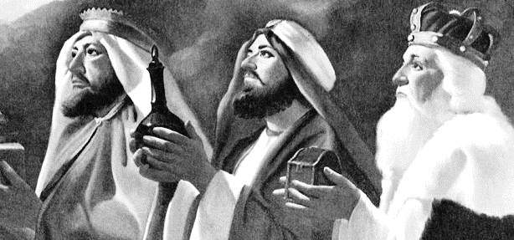
January 2019
Trinity Tidings

After Jesus was born in Bethlehem in Judea, during the time of King Herod, Magi from the east came to Jerusalem and asked, “Where is the one who has been born king of the Jews? We saw his star when it rose and have come to worship him.” Matthew 2:1b-2 (NIV)

I love the festivities and peace filled ambiance of Advent and Christmas as we anticipate the celebration of Christ’s birth. I love the music, lights and all the preparations as the Spirit grabs us and fills us with joy all the way in to a new year. It all goes too quickly though. I remember thinking, as a child, that time moved rather slowly. I thought Christmas would never arrive. I thought I would burst if it didn’t come soon. This kind of eagerness and joy that builds inside of a child is the same kind of anticipation we want to embrace as an adult. Regardless, if we are caught up in the busyness of life or drawn down by the mundane we want seek out this newborn king with the same enthusiasm.

Where, indeed, is the One born of the Jews? Who is this little One and how do we worship Him? Where do we find the Prince of Peace? You and I know Jesus continues to live and breathe among us. We know that He will be found in the most unexpected places; not only in other people, but also in places and things. Jesus will certainly be known through a pet or a moment. God chose to be close. God loved us so much He came to earth – Emmanuel – God with us! Yes, Jesus shines in and around us every day in everything! We are led by the same bright star.

The thing is, we seek the One who has already saved us! We have the advantage because we know the rest of the story. Just as God knew His Son’s path would lead Him to Calvary to save you and me so we, too, know the future of this miniature bundle of joy before the day even arrives. This is the kind of knowledge that will fill us and warm us so that we can more fully experience the gift of the Godchild. Nothing can be added to or taken away from this unconditional love.

Christmas, then, is the time to share this gift of understanding with others. Christmas is the time to stress the importance of the present; not the ones under the tree but the moments God gives us here and now. Christmas offers us a way to worship ‘Magi style,’ and to offer all of our gifts, without exception. Christmas holds us close and gives us hope. Christmas offers us unimaginable gifts as we follow those wise men to the stable.

May your blessings overflow as you unwrap the mystery of this newborn child.
Pastor Cheri

