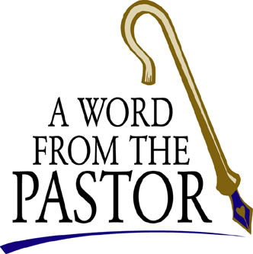
Let the morning bring me word of your unfailing love, for I have put my trust in you. Show me the way I should go, for to you I entrust my life. Psalm 143:8

A colleague of mine mentioned their congregation changed one word in the Apostles’ and Nicene Creed. They replaced Believe with the word Trust. So the Apostles’ Creed would go like this; “We TRUST in God, the Father Almighty, maker of heaven and earth. We TRUST in Jesus Christ, the Son of God, conceived by the Holy Spirit and born of the Virgin Mary….We TRUST in the Holy Spirit, the holy catholic church, the communion of saints…” When taken this way I believe it not only changes the perspective, it expands and dare I say improves the statement of our Christian faith. To believe doesn’t necessarily imply that we will trust God in all things. I mean really, think about it. How many times do we try to carry our own (and others’) burdens – worry weighing upon our shoulders, diminishing our quality of life, consuming us with fear and anxiety when instead, we should be taking in every moment of the day with praise and thanksgiving, acknowledging all our blessings. My friend who has been battling cancer for 4 years tells me everyday is full of blessings. We breathe much easier when we trust God – children trust their parents without hesitation, adults, on other hand, have been disappointed over the years and experienced the reality of sin. We cannot trust anyone as completely as we can trust God to have our back, and to pave the way in behalf of our best interest. TRUST is a big deal. As humans we have to earn one another’s trust, and when we mess up we have to earn that trust back again. But God does not make us earn it even if we could. Jesus sacrificed Himself so that we could bypass all that works righteousness and dwell joyfully in His loving care. That means we trust God to do what’s best for us. That doesn’t mean there won’t be bumps and bruises, but it does mean we will endure those trying times with grace and understanding. I mentioned a few weeks ago that we ought to spend at least 15 minutes a day in prayer and bible study. Martin Luther is quoted to have said he couldn’t afford not to spend at least 4 hours a day before he began his day. I challenge each of us to double what we already do. I am always amazed at how peaceful and smoothly my day runs when I trust God to get me from place to place and to meet the people I need to see and on time (or nearly so). We know how to trust,xxxx.
“Trust in the Lord with all your heart and lean not on your own understanding; in all your ways submit to him, and he will make your paths straight” Proverbs 3:5-6

Pastor Cheri

