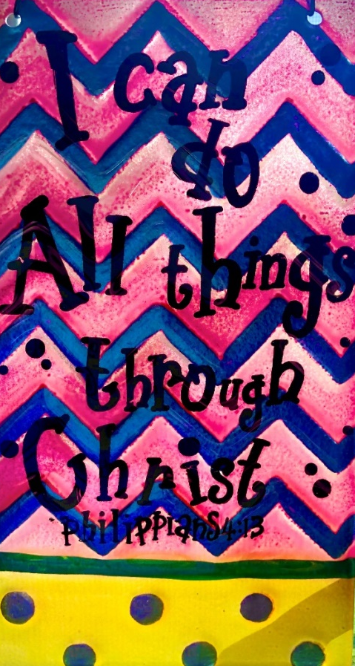
Trinity Tidings
September 2022

“I can do all things through Christ who strengthens me” Philippians 4:13

These ten words are a good reminder to those of us who usually feel we are in control! We have, after all, the intelligence and experience to respond appropriately to just about anything that comes our way, right? Unfortunately, sometimes our pride (and stubbornness) gets in the way, and we do not ask for help. I propose we ask the same question Franciscan Ilia Delio asked, “What will happen if I really trust God’s love for me and allow God to direct my life?” (Center for Action and Contemplation August 21, 2022). If we are honest with ourselves, we might admit that it is because our goals may not align with God’s. We are certain our answer is right and perhaps maybe we distrust God’s Will. Even so, God waits patiently for us to realize our shortcomings and/or that which might be best.
We are never alone because the Spirit already dwells within us! Richard Rohr notes “We can trust that we are being guided [and] start allowing the Divine Flow instead of stopping it with a “no” or a question mark” (ibid.) We limit ourselves and the work of others when we lose faith in ourselves, others, and most importantly in God. As difficult as it is to ask for help it is much easier to turn to God in prayer. God responds to us saying, “Though you are insufficient to handle your troubles by yourself, you and I can handle anything!” (Sarah Young, Jesus Always, p.246). Faithfully repeat this mantra, “I can do all things through Christ who strengthens me.” As children of God, we are clothed in Christ, forgiven, and allowed to do great things in this world. There is nothing we cannot do when God is on our side. All we must do is ask. Granted we may not get the answer we are looking for, but we trust that God knows what God is doing. We must have faith and believe that the “Spirit in us knows how to use everything that happens to bring about healing and growth,” writes Young. “We can trust that “God is even in this!”
What is faith? Faith is trusting God. Faith is more than doctrine, experience, and the stories we tell. Faith is more than a sheer will. Having faith is letting God do the heavy lifting. Why worry when we cannot control the outcome? Why burden our physical and mental well-being because we think we know what’s best? God is good all the time. All the time God is good. Let that be engraved on our hearts and allow the Spirit to pave the way even if we cannot or do not want to.
I recently visited a member from Zion Lutheran at Lancaster General (I am covering for Pastor Kate) who told me she loves to go to YouTube when she needs a “how to” video.” (I am pretty sure I’ve heard that somewhere before 😊). She trusts that she can find whatever she is looking for on the internet. Why can’t we do the same with God? Similar to Googling or YouTubing our answers, we always have a better connection when we fall on our knees, fold our hands, bow our heads and speak directly to the Supreme Being. God is always there, always listening, and always pleased to give us what He sees we need. We just gotta have faith!

“The Lord is gracious and merciful, slow to anger and abounding in steadfast love. The Lord is good to all, and His compassion is over all that He has made. All Your works shall give thanks to You, O Lord, and all Your faithful shall bless You” Psalm 145:8-10.

Blessings, Pastor Cheri

